Linear Algebra for Data Science in R

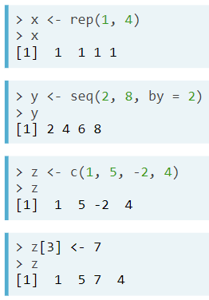**Introduction to Linear Algebra**

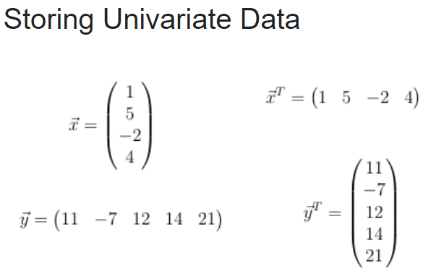

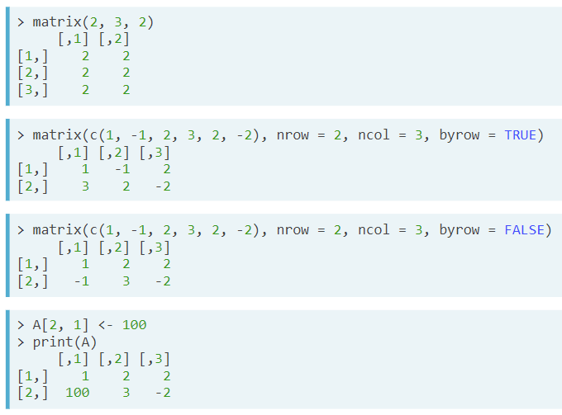

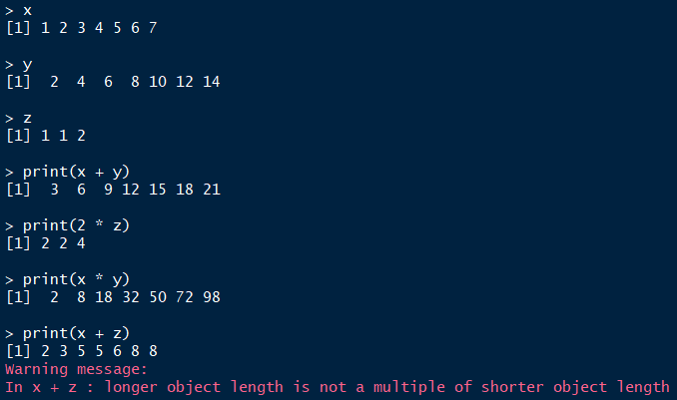

Vector Recycling

Vector Math in R

Matrix-Vector Equations

Eigenvalues and Eigenvectors

Principal Component Analysis